**GOVERNMENT ARTS COLLEGE, OOTY**

**DEPARTMENT OF PHYSICS**



A DATA DRIVEN EXPLORATION OF APPLES IPHONE IN INDIA

MENTOR:

DR.J. MANIKANDAN

SUBMITTED BY

TEAM LEADER:B.AKASH(2126B0046)

TEAM MEMBER 1:B.ARVIND(2126B0047)

TEAM MEMBER 2: G.HARI KRISHNAN(2126B0048)

TEAM MEMBER 3:A.HEWIN KASPER(2126B0049)

**A DATA DRIVEN EXPLORATION OF APPLES IPHONE IN INDIA**

1.INTRODUCTION

1.1 OVERVIEW

The world has changed as a consequence of the increasing use of smartphones, which have improved communication, connected people, and revolutionized many different businesses. With its main product, the iPhone, capturing markets around the world, Apple Inc. has emerged as a prominent player among the top smartphone makers. India, one of the economies with the greatest economic growth, has seen a tremendous increase in smartphone usage, making it an interesting market to study the effects of Apple's iPhone.

1.2 PURPOSE

Marketing insights benefit both parties by meeting your target audience’s needs and wants while also profiting. This is especially true when marketing a previously unused or unknown innovation. In other words, the best market insights help those selling the invention and the companies needing it. They offer value for money.

A company’s ability to gain marketing insights is critical. The following are some of the most common essential marketing insights to increase customer involvement and profitability:

* In order to meet the needs of your [target audience](https://www.questionpro.com/blog/what-is-a-target-audience/) based on their purchasing habits and attitudes, marketing insights are essential. People who have purchased, engaged, or repurchased products or services in the past can provide these insights.

Companies can directly interact with their customers and find out what content, goods, or services they want, and they can meet those demands with marketing insight.

* Understanding the needs and wants of the target audience helps companies better understand their customers’ preferences. This information gives them a much better chance of bringing in revenue. With the help of market insights, marketers can link insights from actual data to create predictive models for their advertising efforts.

For example, suppose a business discovers that its customers are more likely to purchase fruit flavors in the summer months. In that case, they can use this insight to develop a strong marketing campaign for their fruit flavors during the following summer.

* Utilizing market insights is crucial because it aids in predicting potential changes in the market or industry. Finding patterns in customer behavior, such as spending patterns or levels of content engagement, can be done very effectively by [analyzing data](https://www.questionpro.com/blog/what-is-data-analysis/).

Marketers can frequently spot [marketing trends](https://www.questionpro.com/blog/big-idea-marketing-trends-that-can-transform-your-brand/) based on outside variables such as the season, weather, economy, or makeup of their rivals’ markets. With the help of marketing insights, they can predict market changes .

2.PROBLEM DEFINITION AND DESIGN THINKING

2.1 EMPATHY MAP

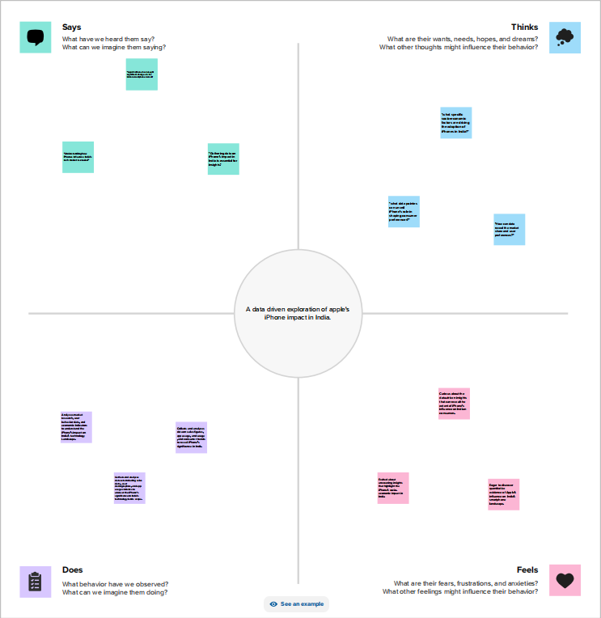

2.1 BRAINSTROM MAP AND IDEATION

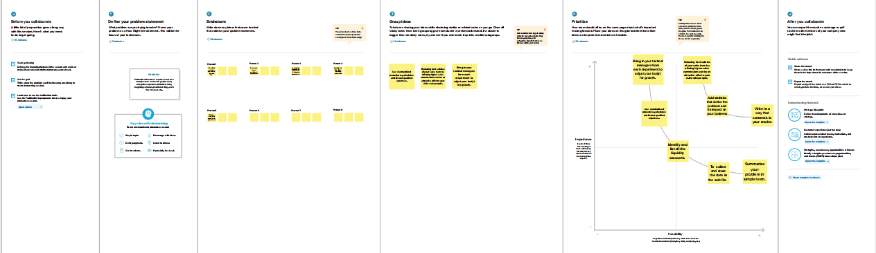

3.RESULT

DASHBOARD

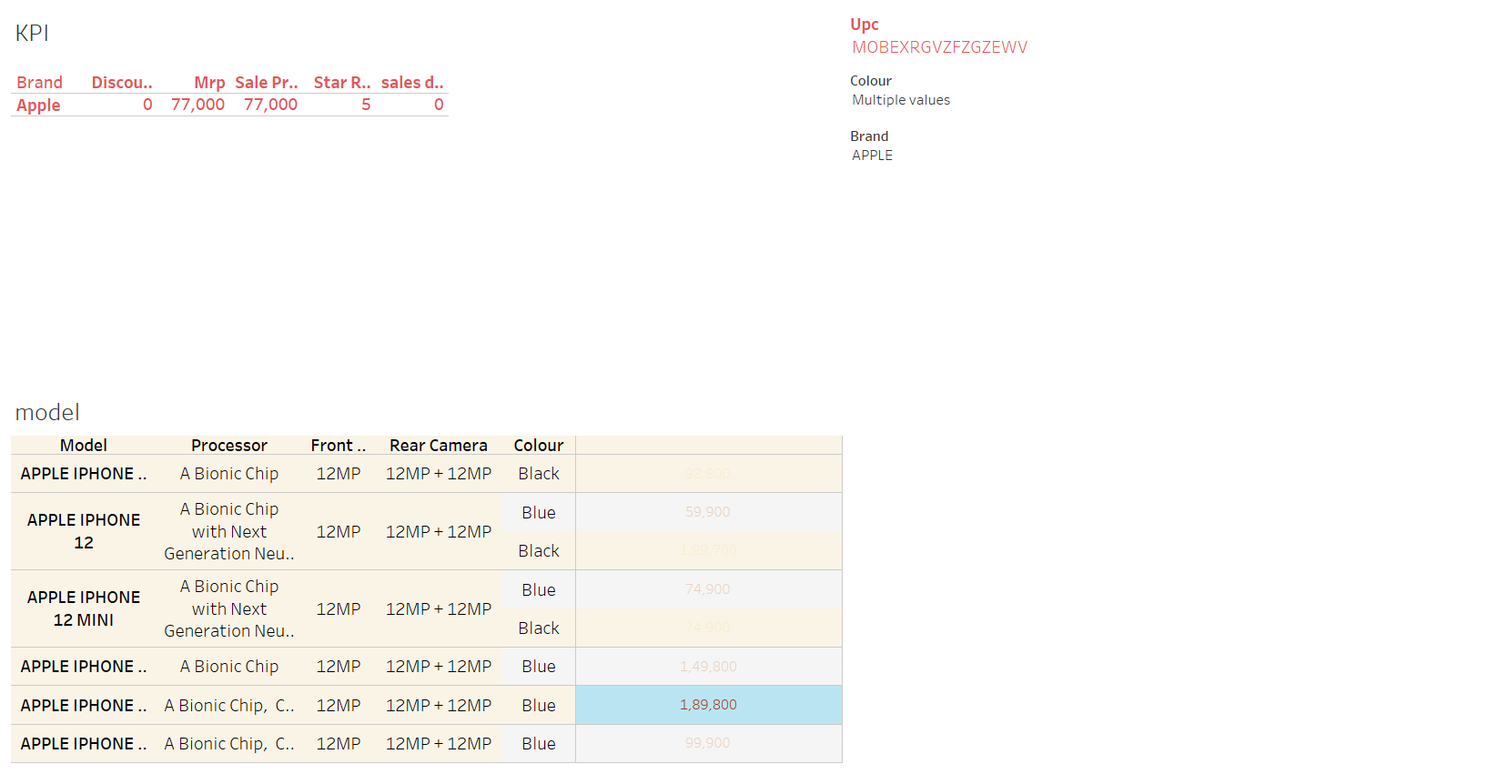

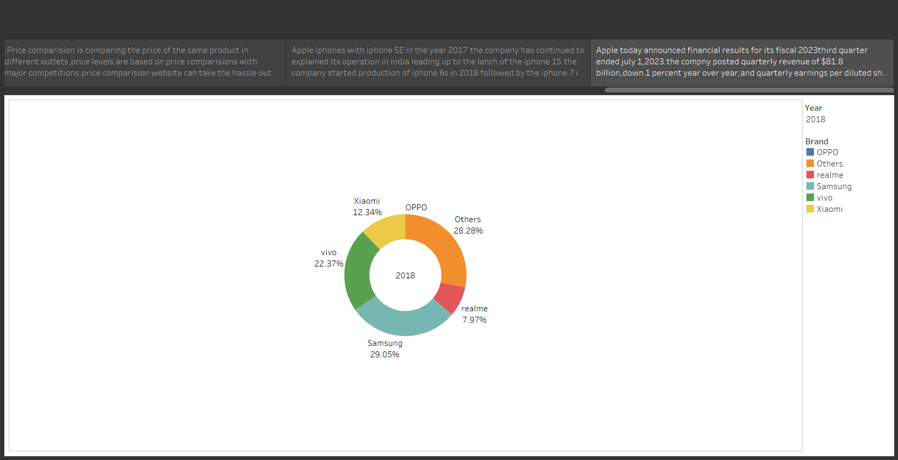

4.ADVANTAGES & DISADVANTAGES

* **Market insights use** acute, subjective analysis to discover relevant, actionable and previously unknown truths about your target market.

* Whether it’s a lack of time or lack **Insightful marketing** reveals how your potential customers view your innovation — helping you **highlight its unique strengths**, translate its technical jargon into effective branding, and more effectively communicate it to a branch.

DISADVANTAGES:

* The first disadvantage is the cost and time involved. Conducting market research can be [expensive](https://www.thefarnsworthgroup.com/blog/market-research-cost" \l ":~:text=In%20general%2C%20you%20should%20plan,to%20overall%20market%20research%20cost.) and [time-consuming](https://dimensionalresearch.com/blog/2009/06/22/how-much-time-does-a-market-research-project-take/), especially for small businesses with limited budgets and resources. The process involves data collection, analysis, and interpretation, which requires investments in terms of time, staffing levels, and technology**.**

**\*** The second disadvantage is the potential for data accuracy and [reliability](https://smallbusiness.chron.com/two-major-errors-can-occur-during-marketing-research-42868.html) issues. The quality of market research data heavily relies on the data collection methods and sample size. If not conducted carefully, there is a risk of obtaining biased or inaccurate data, leading to faulty insights and misguided decisions.

* The third disadvantage is the potential for information overload. With the abundance of data available through market research, businesses may face the challenge of processing and analyzing large volumes of information. Without proper analysis tools and expertise, it can be overwhelming to extract actionable insights from the data.

5.APPLICATONS

* Business analysis services involve the systematic examination of an organization’s operations, processes, and data to identify areas for improvement and growth.

* They leverage various tools, methodologies, and techniques to gather, analyze, and interpret data, ultimately providing actionable insights for decision-making.

* By uncovering patterns, trends, and opportunities within the market, business analysis services assist businesses in making strategic choices that lead to improved performance and competitiveness.

* Business analysis services play a pivotal role in unveiling market insights in Delhi. These [services](https://scrrum.com/) help businesses gather and analyze vast amounts of data, transforming it into meaningful information and actionable recommendations.

* By employing sophisticated analytical techniques, such as data mining, trend analysis, and predictive modeling, business analysts can identify opportunities, anticipate market shifts, and identify risks.

6.CONCLUSION

Market insights are a beacon guiding organizations through the complexities of the business landscape. By leveraging these insights, businesses can make strategic decisions that not only lead to profitability but also foster innovation, customer satisfaction, and sustainable growth. In an era where information is power, organizations that embrace the treasure trove of market insights are better equipped to navigate changes, seize opportunities, and emerge as leaders in their industries.

7.FUTURE SCOPE

* The future lies in having your audience interact with your brand. Interactive content formats like quizzes, polls, informative calculators, interactive microsites, and infographics will become useful for collecting quality leads.

* People who are buying online are always looking for a third opinion while making a purchase. While it’s important for brands to create authority content, it is equally important for opinion leaders to endorse them. There is a lot of content that brands are producing right now, and the audience is looking for social proof to believe in the worth of a product/service.

* AI and machine learning make content production more predictive, personalized and productive. You will see a significant improvement in your website conversion rates by using AI-powered personalized content. AI and machine learning help you to predict audience preferences and provide them with offers that are relevant to them.

* Live streaming is a quick and simple way to promote products/services. Trends show a higher level of engagement with such content posted on social media channels.

**THANK YOU**